OCEAN ACIDIFICATION

OSTEOPOROSIS OF THE SEA
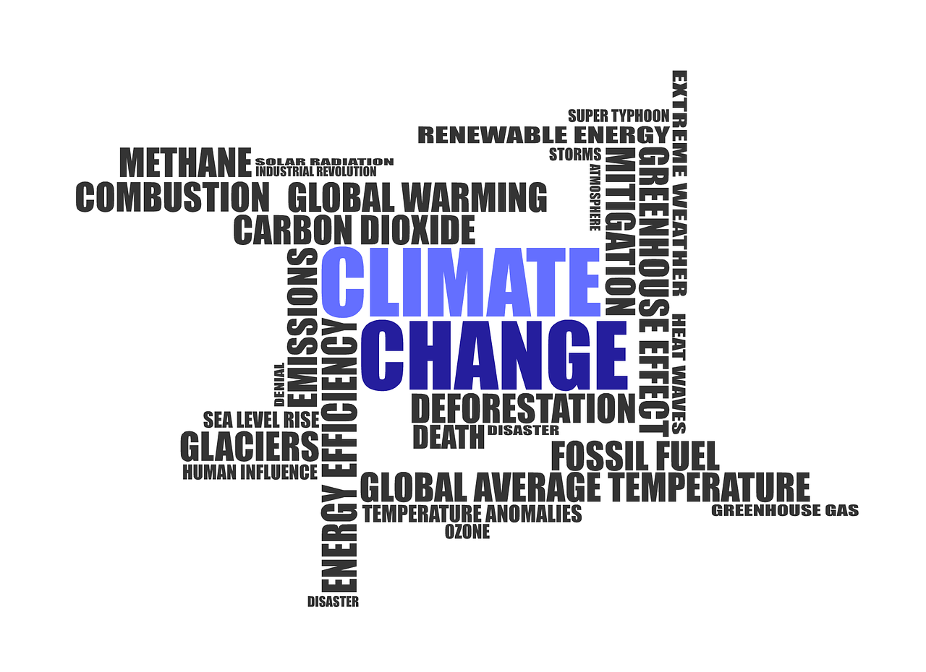

“The Greatest Threat to Our Planet Is the Belief That Someone Else Will Save It.” - Robert Swan, O.B.E.

What is Climate Change?
You’d be hard-pressed to find a human being on the planet who hasn’t heard at least something on the topic of climate change, but how many truly understand it? Climate change refers to changes in weather patterns and growing seasons around the world. It also refers to a rise in sea level caused by the expansion of warmer seas and melting ice caps and glaciers, posing a serious threat to life on earth from widespread flooding and extreme weather.
Over its lifespan, the Earth has experienced subtle climate change, warming, and cooling due to various natural causes, however, the degree of change we’ve seen in the past century is not a natural occurrence, it is a global crisis brought about by increasing amounts of C02 emissions into the atmosphere.
Carbon dioxide (CO2) is an important heat-trapping greenhouse gas, which is released through human activities such as deforestation and burning fossil fuels, as well as natural processes such as respiration and volcanic eruptions. Since the beginning of the industrial era (1850), human activities have raised atmospheric concentrations of CO2 by nearly 49%. This is more than what had happened naturally over a 20,000 year period.
An estimated 30% of greenhouse gasses come from transportation, 25% from power plants that produce the electricity we consume, 23% from industrial production, and the remainder is almost evenly balanced between residential and agricultural sources.
Though this trend has been going on for centuries, its pace has significantly spiked in the last hundred years due to the increased use of fossil fuels. As the human population has increased, so has the volume of fossil fuels burned. Fossil fuels include coal, oil, and natural gas.
Chronic exposure in humans to high levels of C02 can lead to detrimental health effects such as inflammation, kidney disease, respiratory acidosis, and oxidative stress just to name a few. But Humans aren’t the only species to suffer from C02 emissions.

“We are the first generation to feel the sting of climate change, and we are the last generation that can do something about it.” - Jay Inslee

What Does C02 in The Air Have To Do With The Ocean?
It’s easy to see the effects of pollution in the air. Everywhere you look, the evidence is unmistakable in the form of smokestacks belching billows of toxic smoke, automobiles backed up for miles in rush-hour traffic, and that grey layer of smog that blankets most large cities. But, other than some garbage left behind by careless humans, aren’t our oceans clean and clear?
This question is perhaps the reason why science has been so late in identifying the issue of ocean acidification as a result of increasing levels of C02 emission in the atmosphere.
When carbon dioxide mixes with seawater, it forms carbonic acid. This introduction of acid reduces the pH balance in the ocean environment, making it more acidic.
This is particularly concerning for corals. Many people believe corals to be a rock or a plant, however, corals are actually living creatures made up of hundreds to hundreds of thousands of individual animals, called polyps. These polyps are soft-bodied creatures who make hard outer skeletons by combining calcium and carbonate from the seawater.
Tragically, corals and other shell and skeleton-making organisms are suffering catastrophic consequences from ocean acidification. As acid increases, carbonate decreases, preventing these organisms from building and maintaining their shells and skeletons. Some shells and skeletons can even dissolve.
The disappearance of corals from our planet could lead to a domino effect of mass destruction. Many marine species will vanish after their habitat and food sources disappear. The danger exists for humans too. There may be a serious food crisis in coastal regions that subsist primarily on a diet of fish as a number of fish die-off. Coral reefs also provide protection against flooding and erosion of coastlines.

Can This Problem Be Solved?
YES! Incredible organizations like WellPlanet Project are creating state of the art C02 Capture and Sequestration technology designed to:
- REMOVE CARBON DIOXIDE - By relying on groundbreaking technology in direct air capture and sequestration, our facility will remove up to 10 megatonnes of C02 every single year. Our efforts will take the strain off of our struggling ecosystem that is currently trying - but failing - to convert all of our C02 emissions into 02.

- STORE IT UNDERGROUND - Our primary focus isn’t to turn a quick profit by capturing and reselling C02 for enhanced oil extraction or to carbonate beverages. To us, this is simply another way that C02 ends up back in our environment. Instead, we’re using a solar and geothermal-powered facility to capture as much C02 as possible and permanently remove it from our ecosystem using deep underground geologic storage.

- REPEAT AD GROW - Our facility will remove the same amount of carbon dioxide as 400 million mature trees, which is amazing but we know that is not enough. That is why we will continually reinvest the support and funding from our partners, investors and community to continuously grow our current facility and to develop new ones each and every year.

What Can I Do To Help?
There are many ways you can help this cause.
GET INVOLVED! - Our goal is to mitigate climate change and we know that can’t be done alone. We’ve created opportunities for everyone. Be part of the solution. Every little bit helps! Click here to see how you can get involved. You could even win a Tesla!
PARTNER WITH US - Partnerships that create synergistic value are the key to success. We are actively seeking strategic partners with like-minded businesses. We look forward to being your most valued business partner and leveraging our synergy to help change the world. Click here to learn more about becoming a WellPlant Project Business Partner.
INVESTOR - We can help tax equity investors benefit from the 45Q tax credit. Let us send you a prospectus detailing how the investment works. Investing in WellPlanet will reduce your tax bill while helping to save the planet. Remember we are all in this together. Click here to learn more about becoming an Investor/Sponsor of WellPlanet Project.

